 | INTERNATIONAL TELECOMMUNICATION UNION |  |  |  | COM 12 – C 337 – E
 | TELECOMMUNICATION  STANDARDIZATION SECTOR  STUDY PERIOD 2009-2012 |  |  | May 2012
English only
Original: English
Question(s): |  | 7/12
STUDY GROUP 12 – CONTRIBUTION 337
Source: |  | A1 Telekom Austria AG
Title: |  | Draft P.STMWeb

Scope
This Recommendation describes the method and procedures for subjective testing of user perceived quality of web browsing. The method does generally apply to degradations and characteristics that can be introduced on the network level (e.g. round trip time, downlink and uplink bandwidth, packet losses etc.) but as well on the application level (page load times etc.). Combinations of two or more of such factors have to be catered for.

References
The following ITU-T Recommendations and other references contain provisions, which through reference in this text, constitute provisions of this Recommendation. At the time of publication, the editions indicated were valid. All Recommendations and other references are subject to revision; users of this Recommendation are therefore encouraged to investigate the possibility of applying the most recent edition of the Recommendations and other references listed below. A list of the currently valid ITU-T Recommendations is regularly published. The reference to a document within this Recommendation does not give it, as a stand-alone document, the status of a Recommendation.
[ITU-T P.800] ITU-T Recommendation P.800 (1996), Methods for subjective determination of transmission quality.
[ITU-T P.800.1] ITU-T Recommendation P.800.1 (2006), Mean Opinion Scores (MOS) terminology.

[ITU- P.910] ITU-T Recommendation P.910 (2008), Subjective video quality assessment methods for multimedia applications
[ITU-R BT.500] ITU-R Recommendation BT.500 (2012), Methodology for the subjective assessment of the quality of television pictures
[ITU-T Y.1540] ITU-T Recommendation (2011), Internet protocol data communication service – IP packet transfer and availability performance parameters

[ITU-T Y.1541] ITU-T Recommendation Y.1541 (2011), Network performance objectives for IP-based services.
[ITU-T HSTP] ITU- T, Handbook of subjective testing practical procedures

Definitions
This Recommendation defines the following term:
Condition: time period in which a defined QoS setting is applied for a certain web page. A condition is concluded by retrospective user ratings on one or multiple dimensions of quality.
Task: is a given set of instructions given to the user on how to reach certain information within one test condition.
Web browsing session: A web browsing session (WBS) starts with a user’s intended, initial request of a web page to achieve a certain task and ends with its fulfilment. Typical for such a session is the engagement of the user in a flow through several consecutive web page views.

Abbreviations and acronyms
This Recommendation uses the following abbreviations and acronyms:
DLBW Downlink Bandwidth
MOS Mean Opinion Score
PL Packet Loss
PLT Page Load Time
RTT Round Trip Time
ULBW Uplink Bandwidth
WBS Web browsing session.

Conventions
The methodology discussed within this recommendation is tailored for web browsing only. Browser-based applications such as online office applications, webmail etc. might be evaluated by the same means, but they have to consider different scenarios depending on the defined tasks during subjective evaluation and the technical implementation of the services
The focus of this recommendation is set on the evaluation method of the complete WBS to achieve and maintain a flow experience of web browsing for better external validity of the test results. However, this methodology’s test setup with respect to test facilities, test conditions, subject selection, and test devices is also applicable to the subjective evaluation of single web page loading times.

Web browsing test procedure

Purpose
Subjective quality tests for web browsing aim at assessing the impact of transmission impairments on the user perceived quality of a web browsing session under realistic usage conditions.
The main characteristics of a subjective web browsing test are:
- To be very close to real web browsing where people are browsing and interacting with web pages in order to acquire certain information, the procedure they go through within this methodology ensures that people get into a browsing mode rather than a pure page loading mode.
- Subjects are exposed to a certain QoS level over a time period rather than for one event, in order to grasp several request-response cycles for the subjective evaluation.
- The use of certain tasks to stimulate the interaction between the web page and the subject for each test condition.
- The content e.g. the web page must be interactive and has to provide sufficient content such that the subject can browse through it over several conditions without getting bored.
- This test methodology can be adapted to field testing; however, it is has to be ensured that the manipulated parameters (e.g., delay, packet loss, downlink bandwidth, etc.) can be set to the desired values and that these settings can be verified by a posteriori analysis (e.g. traffic traces).
The results obtained with this methodology, can be used by telecommunication providers, vendors and customers to get information of the influence of the tested technical parameters on end user perceived quality.

Test facilities
Typically, test facilities for subjective web browsing evaluations do include an end user device, a network emulator, a router, and some optional components as depicted in in Figure 1below. Network parameters are set through a network emulator (EMU) which is placed between the user device (UD) and the router (RT), which ensures the routing between eventual local content servers and the internet.
When using live web pages within the evaluation one has to ensure the measurement of the page health in order to identify potential influences due to congestions or server malfunctions through a page health monitor (PHM) connected to the internet via the router as indicated in Figure 1. . In case multiple subjects participating in parallel it must be ensured that each subjects receives the obliged parameters, hence shared channel settings have to be avoided.
If web pages are used including video content that is also affected by the test parameters, requirements for the lab facilities from ITU-T P.910 apply in addition.
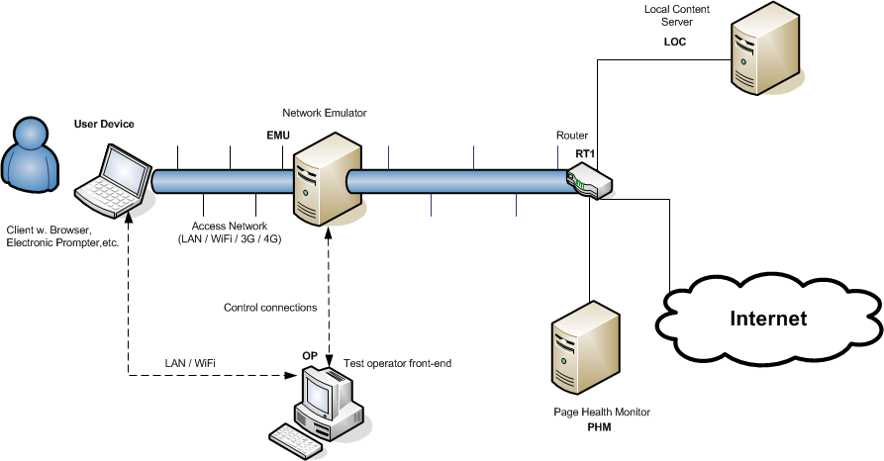
Figure 1: Example of test facilities

End User Devices
The end user device has a major impact on the overall performance as perceived by the user. Therefore, detailed reporting about the device characteristics and setting are essential. If the end user device or only any of its characteristics are considered to be a variable parameter of the quality evaluation, then all applied variations must be reported.

Hardware
Due to the high dynamics in web technology developments it is viable that recent hardware is used for the tests in order to ensure that device performance does not dominate the chosen test variables unintended.
At the time of drafting this recommendation hardware can be roughly classified in four categories (a) PC / Laptop, b) Tablets, c) Smartphones, d) other devices that are able to connect to the web). Typically, these four categories feature different performance issues. Therefore, one should only use devices of different categories in case they are part of the condition variables under test.
Displays should be calibrated to D65 at the beginning of the test if possible (might not apply to device categories b, c, d); subjects must not be allowed to modify the luminance levels.
For each of the devices used within a test the technical details have to be included in the reporting as detailed in Appendix III.

Software
Regarding the operating system of the devices, the latest versions of major operating systems should be used with all updates applied. The software related details that have to be included in the report are enlisted in Annex I

Browser
For the device categories b), c) and d) it is recommended to use the default browser as these are optimized in several ways for these devices. In case of category a) the latest version of a major browser should be used. However, one might apply older legacies of browsers if needed to run special browser extensions. Regarding these browser extensions, as few as possible extensions should be used to ensure the performance of the browser.

Test Content
For the content selection typical web pages should be chosen. On has to ensure that the web page is well programmed and its server infrastructure is fast and reliable also across peak times. It is recommended that server performance is monitored over one week before a web page is chosen as test content.
Content types and examples: news page (www.spiegel.de), photo album (locally hosted), web shop (www.amazon.de). The content examples are chosen such that they reflect typical web pages frequently browsed by German Internet users.
Web page characterization → separate Annex B

Test design
The flow characteristics of web browsing demand condition lengths with several technical request-response patterns (Ref. C-0236). Therefore, a web browsing session of min. 150 sec is recommended which is then followed by the retrospective ratings on the dimensions of overall quality, perceived speed and stability of the connection. Including the ratings one condition is of about 180sec length. Such a length is a reasonable trade-off between achieved user flow and practical considerations such as number of possible conditions and maximum overall test duration. A maximum active test duration of two 45 min blocks separated with a 10 min is recommended (Ref: JAES Journal). In addition an instruction block in the beginning and a debriefing block in the end are also recommended. The overall duration should not exceed 120 min. An example of a test schedule with 24 test conditions is shown in Table 1.
Compromises have to be made between the test duration and the choice of conditions. If more conditions are to be tested, different experiments and may require a between-subject or balanced incomplete block design. The order of the conditions should be pseudo randomized, e.g. by means of Latin Squares or other experimental designs as described in Section 3.3 / [ITU-T HSTP].
Each test subject should be seated in a realistic environment according to the chosen scenario. Beginning and end of each condition must be clearly indicated to the test subject to ensure ratings corresponding to the experimental parameters set. However, care has to be taken to make these notifications clear but also not too intriguing to keep the subject in the web browsing flow.
After arrival of the subjects an instruction has to be conducted where the nature of the test and the tasks are explained. This should be followed by a training session in which the participant goes through all different tasks given to ensure correct understanding and execution of the tasks and in which he practices the use of the scales to rate the quality retrospectively. The training session should also ensure that parameter values from the lower end and the higher end of the parameter range are used in order to acquaint the subjects with the parameter range to be expected throughout the test. In addition it has to be ensured that the parameter ranges are chosen such, that the whole range of the scale is used

 | Instruction | Training Session | Session 1 | Break | Session 2
Number of test conditions |  | 3 | 12 |  | 12
Time | 15 mins | 9 mins | 36 mins | 10 mins | 36 mins
Table 1: Test schedule for 24 conditions

Test conditions
Typically for web technologies services are delivered via IP networks. These networks are nowadays available in fixed and mobile scenarios with different network characteristics and are accessed with different devices. For the design of the test this has to be considered in order to achieve a realistic scenario for the test. A more detailed discussion regarding IP parameters can be found in [ITU-T Y.1540] and [ITU-T Y.1541]
Examples of test parameters are:
On a Network level:
- DLBW / ULBW
- RTT
- Temporal fluctuations of DLBW, ULBW, RTT
- Etc.
On an application level :
- PLT
On a device level :
- Devices (PC, Laptop, Tablet, Smartphone)

Subjects
Special care should be taken when selecting subjects for tests with tablet and smartphone devices. As these devices are not as widespread as PC’s some potential subjects will be more experienced than others. It is recognized that the levels of experience with specific equipment or technology is a continuum ranging from those who are completely unfamiliar with technical behaviour of the equipment under test ("non-experts") to those who are thoroughly competent in the operation and maintenance of this equipment ("experts"). Another criterion for subject selection to be considered in web browsing is the subject’s experience and regular usage of the test content. It is noted that good knowledge about the structure and usual behaviour of the test web page can have a severe impact on the sensitivity due test parameter changes of test subjects.
In order to ensure that the influence of the above mentioned experience with the devices and web pages under test are minimized it is recommended that the selected subjects are experienced with the devices under test and the web pages used.
Unless gender, age and other socio-economic characteristics are design factors of the test, then a formal web browsing test should be populated (on a best-endeavour basis) with a random mix of subjects.
Age and gender as well as socio economic characteristics of all types of subject should be recorded for all types of tests.

Tasks
In general, two different modes for the task during a WBS can be defined. The free-browsing mode does not require specific goals to be achieved during the session. Subjects are asked to explore the test content on their own by requesting several web pages. In the task-dependent mode, specific tasks are defined the subject shall perform on the web pages. The end of such sessions can be determined either by a specific number of web pages requested and loaded consecutively or by a given session time.
In general, the task shall be intrinsically motivating and easily solvable without training. Additionally, the task accomplishment mustn’t be limited by existing/known usability problems to avoid unintended impact of task design on test parameters. To avoid boredom, tasks should include a logical structure and relationship to the purpose of the website (e.g. look for offers on shopping page or look for information on the latest headline on a news page). Examples of suitable tasks for different website classes are included in Appendix II.

Questions
Single or multiple dimensions of perceived quality are evaluated retrospectively after each test condition. Examples of absolute category scale questions and labels as well as a binary response scale are given below. It is noted that the actual questions chosen for the test are dependent on the research question to be answered and might exceed these questions. Further examples of questions for other dimensions of interest are given in Annex III. However, it has to be considered that the cognitive load on the subjects and therefore the number of questions asked should be kept as low as possible in order to reduce any possible confusion and subject fatigue.

For the general assessment of the perceived overall quality of a test item:

“Please rate the overall quality of the connection you have been using on the following scale”
The scale descriptors are:
• Excellent
• Good
• Fair
• Poor
• Bad

For identification of quality thresholds with respect to acceptance of the condition:
Please note that a context must be defined for the threshold. (e.g. accept quality for your internet connection at home; accept quality for the price paid for the service). The context reference is indicated by the underlined words in the example question.

"Would you accept this connection quality in normal life at home?"
• Yes
• No

The previous examples should be supplemented by the experimenter to address the needs of the specific experiment. When using multiple scales for assessing the multi-dimensional aspect of quality, care should be taken to ensure that the previous responses are not available to the subjects.

Data analysis and report

Analysis methods
Regarding the analysis methods the recommendations from [ITU-T P.800] and [ITU-T P.805] and Section 6 / [ITU-T HSTP] do apply.
Considering the small sample sizes achieved, one can in addition to the analysis methods mentioned in the above references, also use non-parametric statistical hypothesis tests such as Mann-Whitney U, Wilcoxon signed rank tests and others.

Reported results
The report must contain the questions and the category scales used. Due to the possible influence from the setup itself it is also mandatory to report the following setup facts in detail: Browser used, browser version, Plugins used date of the test,
Summary results should include, as a minimum, mean ratings and standard deviations for all tested conditions and for all questions. If the experimenter expects a gender pairing effect, this special case should be also considered in the design of the experiment and particularly in the pairing of subjects. This effect should be analysed and reported.
A list with mandatory structure and reporting details is attached in Appendix III.

Report on the test design
Each report must contain the webpages used, the browser version used, time of the test, Additional plugins used.
Annex A
Result reporting: Mandatory structure and details
This appendix forms an integral part of this Recommendation

Test Setup

Test participants
A description of the user sample used has to include at least the following details (a more detailed description is of course possible):
- Number
- Mean Age
- Median Age
- Gender
- Web usage (hours per week for each participant)
- Experience with web pages (average visits per week)

Test parameters
In this section, all independent variables, which were varied throughout the duration of the test have to be enlisted with their respective parameter ranges.

Web Pages used
For the used web pages the following details have to be reported:
- URL
- Start and end date of the test
- Web page class (e.g. news, photo album, geo location, web shop etc.)
- Web technology used (HTML, Ajax, Flash, Java etc.)
- Average page size in kByte, standard deviation of the page sizes
- Average elements per page, standard deviation of elements per page

Test facilities
The test facilities such as the environment the test were conducted in and the technical setup used have to be reported in this section such that a replication of the test facilities can be achieved by a third party.

Test Devices
For the devices used throughout the test the following details have to be reported:
Hardware:
- Brand
- Model Number
- CPU (type, speed)
- RAM (MB / GB)
- Screen diagonal
- Screen resolution (Pixel horizontal x Pixel vertical) and in case the browser window is not maximized, its resolution has to be reported additionally.
- Screen luminance
Software:
- Operating system + built number
- Browser + version number
- Enabled browser extensions + version numbers
- Any kind of speed optimization used (e.g. http pipelining)

Questions used
All question used for the evaluation of the user perceived quality on several dimensions have to be reported in their exact wording in this section. The scale types used (ACR-5, ACR-9, ACR-11) have to be included in the report as well.

Result Presentation

Acceptance results
For each condition tested and the following details have to be reported:
- Number of positive ratings
- Number of negative ratings
- Number of no responses

MOS results
For each condition tested and the following details have to be reported:
- Mean
- Number of responses
- Standard Deviation
- Minimum and Maximum rating
For graphical result presentation confidence intervals have to be shown and their properties (percentiles etc.) have to be reported.

Annex B
Web page categories
This appendix forms an integral part of this Recommendation
Appendix I
Example of instructions for the web browsing test
(This appendix does not form an integral part of this Recommendation)

INSTRUCTIONS TO SUBJECTS
In this experiment we are evaluating the connection quality of internet connections. Therefore you are asked to browse through various web pages, solve different tasks and rate the perceived connection quality. Please concentrate on the quality of the internet connection and don’t get biased by the content of the web pages.
After completing each condition, you will be asked to give your opinions on the connection quality by answering the questions displayed on the laptop in front of you. Please answer those questions intuitively. The scale is ranked from very poor to excellent, whereas “very poor” is the worst and “excellent” is the best connection quality, which you can imagine. After clicking the “save” button, your judgement will be stored. After filling out the form, please continue with the task, until you get further instructions.
Below you can see an explanation to all questions you will be asked.
" Please rate the overall quality of the connection you have been using on the following scale
Bad | Poor | Fair |  | Good | Excellent
"Would you use/accept this connection quality in normal life at home?"
 |  | No | Yes
You will have a break after approximately 45 minutes. In total the test will last approximately 120 minutes.

Appendix II
Example task instructions for the web browsing test
Photos

Task
- Please choose one of the photo albums on the start page.

- Select the first picture preview and wait until it’s completely displayed.

- Now browse through the album by clicking on the “next” button or direct on the picture. Please view each picture for at least 3 seconds.

- For each photo task note the numbers of the five pictures you like most and the five pictures you dislike most.
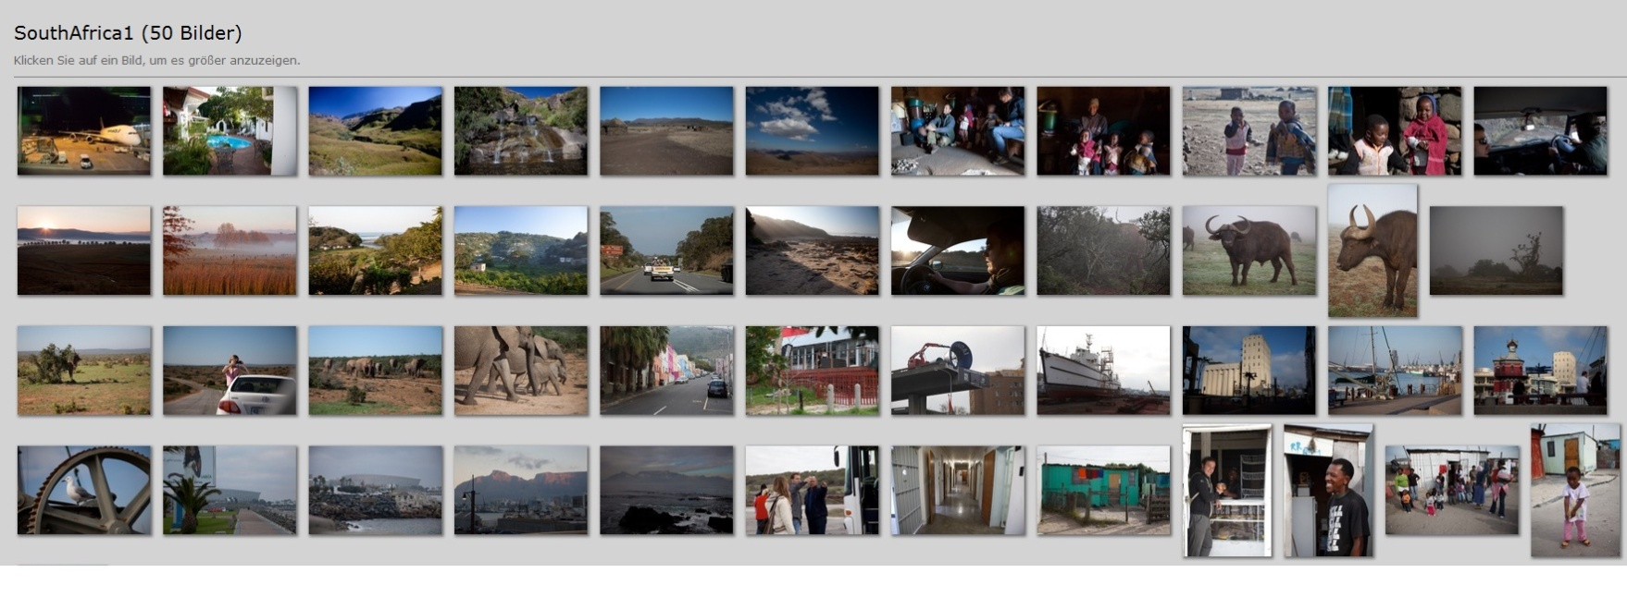

News Page
URL: http://www.spiegel.de/
Task:
Try to get an overview of the current news in the [Economy, Politics, Sport, Culture, ] section. Also click into the articles to get an impression of the topics covered (but please do not read the articles completely). Please keep in mind, that we ask you to rate quality of the internet connection, therefore you should be able to form an opinion about it. Please continue reading articles in one resort, until you’ll get the order to select the next resort. Please stay on the NEWS section of the page!

Comment: ideally you browse through 2-3 articles per minute

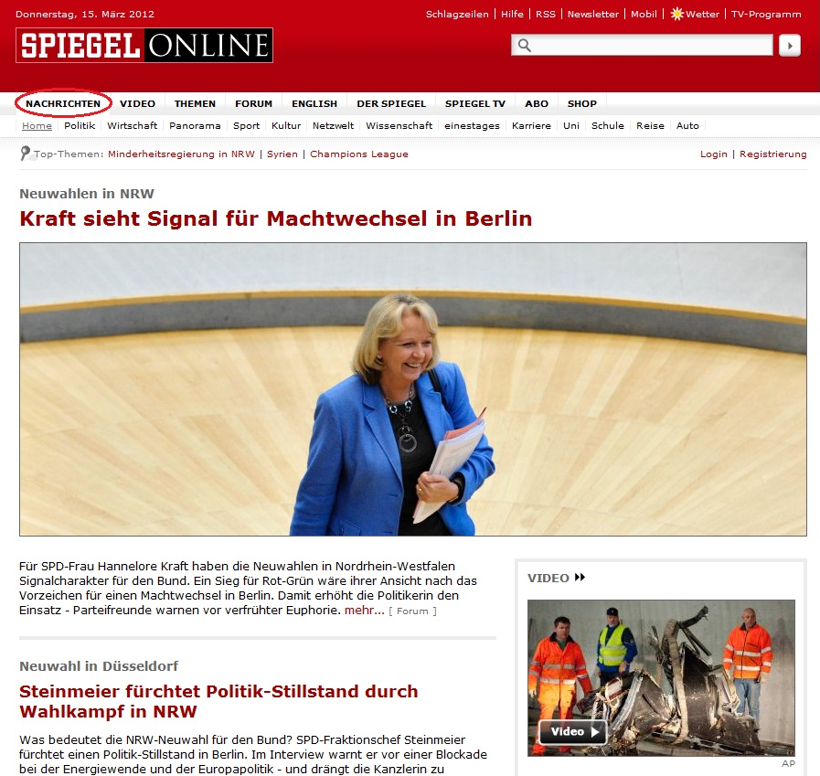
Please do not surf the video or the picture section of the page, we are just about news-articles (text and picture)!
Navigation Task
You are planning a weekend trip to Vienna, with an overnight stay at a hotel and a little bit of sightseeing.
- Open the start page by using the link on the left top of the screen.

- Browse to „Vienna“ (by using the search field)

- Change to the satellite view. (Just click on the „satellite“ button on the right top of the map.)

- Look for a hotel on the Kärntnering in Vienna.

- Hint: Insert „hotel, Kärntnerring“ to the search field.

- Browse through the found hotels (by zooming and panning).

- Look for the hotel, which is nearest to „Minoritenkirche“.

- Find the „Naturhistorische Museum“, the „Bestattungsmuseum“ and the “Arsenal” in Vienna

- Get the directions between the named museums. Start and endpoint is your hotel.

- (To get the directions, click on the „get directions“ button on the right side of your screen. Choose the starting point and add as much destinations as you’ll need – right below the input field, is a „add destination“ link. Finally click on „Get directions“.)

- Zoom in so that you will be able to see the street names (by using the mouse wheel or the „+“ at the left top of the map.)

- Explore the route (by panning).

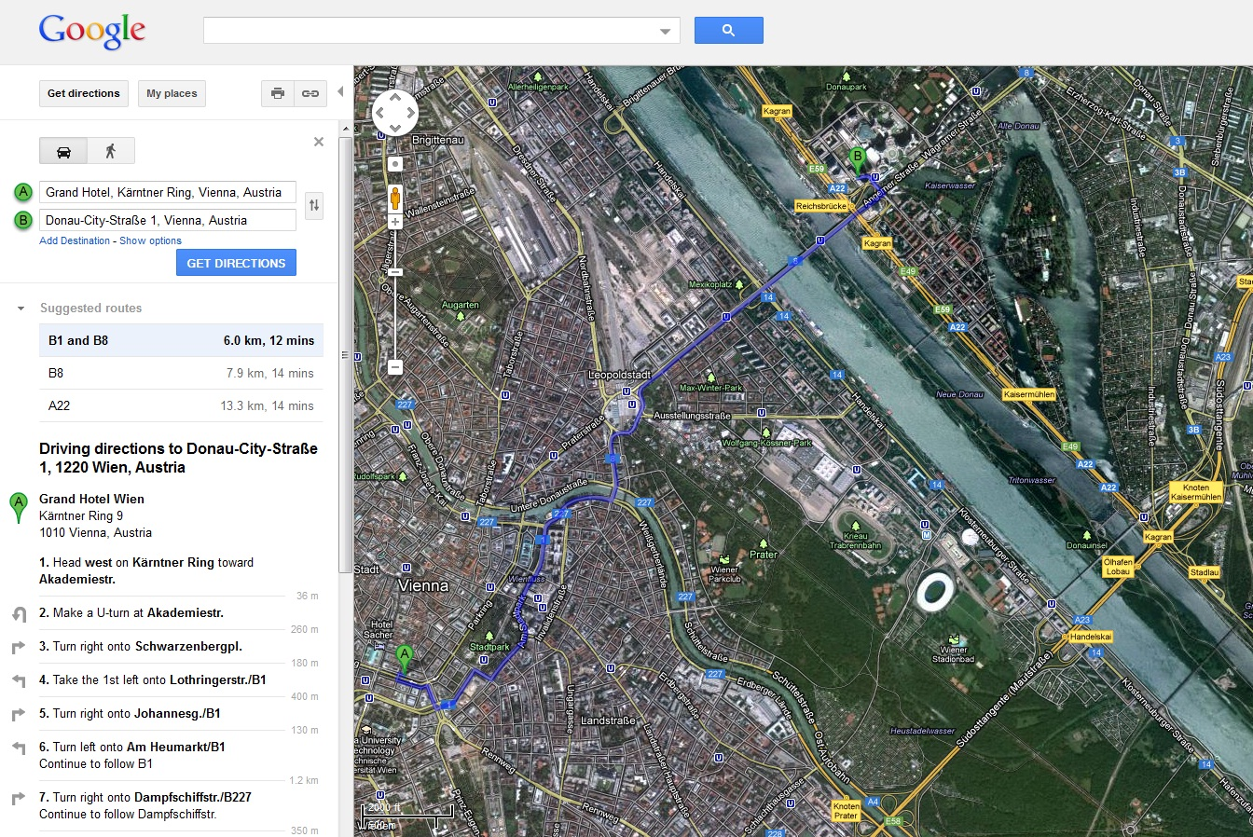
- Change the destinations. Start at your hotel and get the direction to „Donau City Str. 1“.

Web Shop
URL: http://www.amazon.at
Please search for literature of choice. Suggestions:

- Look for holiday reading material.
- Search for an interesting book about Barack Obama.

- Find a serious book regarding covering the reasons of the financial crisis.

- Check the current Amazon charts for literature.

- Search for a tourist guide for your next holidays.

- Find the new book of Ken Follet.

- Look for a self-help book on the subject of “Burn Out”.

- A cookbook with spring recipes.

Warning: Please DON’T watch any videos!

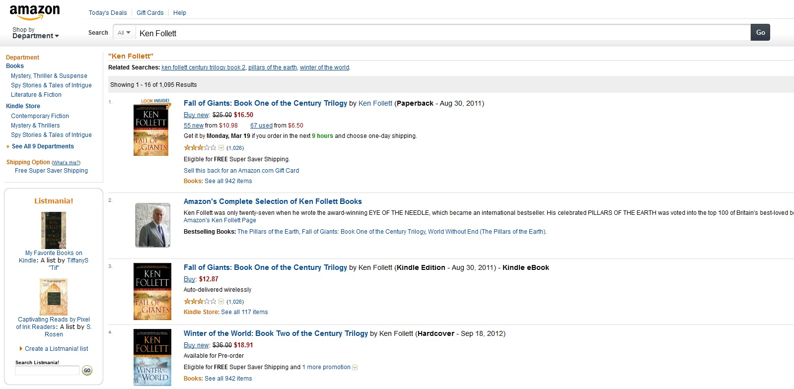

Appendix III
Example of questions for web browsing tests
(This appendix does not form an integral part of this Recommendation)

III.1 For assessment of media quality
Other examples then listed here can also be found in [ITU-T P.910] and [ITU-R BT.500]

III.1.1 “Please rate the image quality on the following scale”
The scale descriptors are:
• Excellent
• Good
• Fair
• Poor
• Bad

III.1.2 “Please rate the video quality on the following scale”
The scale descriptors are:
• Excellent
• Good
• Fair
• Poor
• Bad
III.2 For assessment of the temporal aspects

III.2.1 " Please rate the speed of the page rendering on the following scale "
The scale descriptors are:
• Excellent
• Good
• Fair
• Poor
• Bad

III.2.2 " Please rate the variability of the page rendering speed on the following scale (Excellent = very low variability, Bad = high variability)"
The scale descriptors are:
• Excellent
• Good
• Fair
• Poor
• Bad

_____________

